Lehigh Valley Cat Club
presents its Thirteenth Allbreed & Household Pet Cat Show

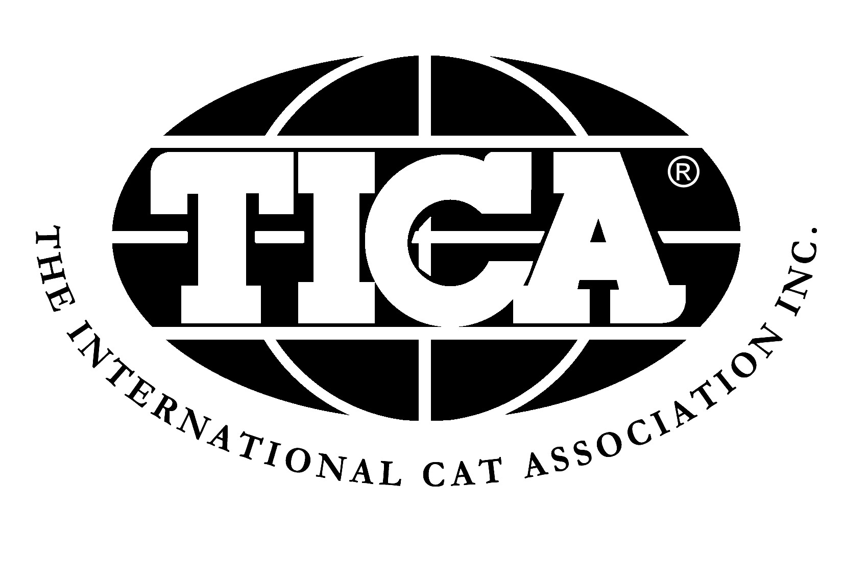

Summer Is Coming
April 19-21, 2019
The Riveredge
2017 Bernville Rd
Reading, PA 19601
http://www.riveredgedining.com/
Our Judges
Friday |  | Saturday |  | Sunday
Barbara Ray | AB | Lindajean Grillo | AB | Yvonne Patrick | AB
Laurie Schiff | AB | Paul Lahey | AB | Lindajean Grillo | AB
Marion Schiff | AB | Fate Mays | AB | Barbara Ray | AB
Brenda Russo | AB | Vicki Jo Harrison | AB | Robby Whyte | AB
Nikki Crandall-Seibert | AB | Toni Jones | AB | Alex Marinets | AB
Fate Mays | SP | Yvonne Patrick | SP | Angela Sherzer | SP
Angela Sherzer | SP | Alex Marinets | SP

Show Manager  Susan Adler  RR #1 Box 269A  Effort, PA 18330  nycsa@aol.com | Entry Clerk  Cheryl Leigh Chamberlin  1512 Berkley Pl  Willow Grove, PA 19090  entryclerk@ticama.org  215-738-3767 between 9AM and 9PM | Vendors  Susan Adler  RR #1 Box 269A  Effort, PA 18330  nycsa@aol.com

SHOW HOTEL: The Inn at Reading, 1040 N Park Rd, Wyomissing, PA. phone: (610) 372-7811. Group rate is $94.00 plus taxes and a $30.00 REFUNDABLE pet deposit. Lehigh Valley Cat Club will enforce the TICA Hotel Room Inspection Policy.
AIRPORT AND TRANSPORTATION TO HOTEL: Lehigh Valley (ABE) and Philadelphia (PHL) are the closest airport options. You will need to arrange transportation to/from the airport.
CHECK-IN: Check in will be from 2PM-3PM on Friday and 8AM-9AM on Saturday. Judging will begin promptly at 3PM on Friday, 9:30AM on Saturday and 9AM on Sunday. Published show hours are 3-8PM Friday, 9:30AM-4PM Saturday and 9AM-3PM Sunday. No cats may remain in the show hall overnight.
CAGES AND SUPPLIES: Benching cages of standard sizes (approximately 22” X 22” x 22”) will be provided for each entry. Two (2) kittens or one (1) cat are permitted in a single cage. All cages must be covered on the top and three sides. Please bring your own litter pans, food and dishes. Litter will be supplied but may be in short supply. People food will be available in the show hall and hotel. Please inform us if you will be using a private cage (please mark on summary sheet).
HOUSEHOLD PETS: Household pet kittens (ages 4-7 months) and adults (8 months and older) are welcome to enter. All adult HHP entries must be altered (spayed or neutered). If you are unsure of the proper color class for your pet, include a full description or a photo (photo will be returned with confirmation.)
KITTENS: Kittens entered for competition must be at least four months old on the first day of the show (born on or before December 20, 2017). Kittens for sale must be at least three months old on the first day of the show (born on or before January 20, 2018). TICA litter registration must be available upon request of show management.
SHOW RULES: By entering, all exhibitors agree to abide by the decisions of the judges and the show committee and the TICA show rules. Official show rules may be obtained from TICA, P.O. Box 2964, Harlingen, TX 78551, (956) 428-8046 or www.tica.org.
REGISTRATION: With the exception of ANB, PNB and NT, registration with TICA is not necessary to compete in a cat’s first show, but is required for the next show and confirmation of titles and TICA Regional/International scoring and awards.
THIS IS A NON-VETTED SHOW: All cats/kittens entering the show hall should be inoculated against Panleukopenia, Rhinotracheitis, Rabies and Calici virus and tested negative for Feline Leukemia. Please clip claws (front and back) prior tobenching. Any cat/kitten showing signs of contagious illness, ear mites, fleas or fungus will be removed from the show hall, as well as any other cats/kittens exhibiting from the same household. Any cat which is obviously pregnant or lactating will be disqualified.
SUMMARY SHEET: Please complete the summary sheet and return with entries and fees. Fee totals must accompany entry forms. NO REFUNDS. We will call collect if significant questions arise regarding your entries. A fee of $25.00 plus any bank fees will be charged on all checks returned for any reason.
CLERKS AND STEWARDS: Please mark your summary sheet if you are interested in clerking and/or stewarding. We need clerks and stewards! Clerks will be paid $35 per day and stewards will be paid $20 per day. Lunch will also be provided. Please do not deduct clerking fees from your entry fee.
HOLD HARMLESS POLICY: By entering this show, the exhibitor named on the entry form/summary sheet holds harmless Lehigh Valley Cat Club, The International Cat Association (TICA), the Riveredge and the Inn at Reading of any damages, claims, or theft as a result of any action/conduct related to the operations of this show. The opinions expressed in publication are those of its authors alone and do not reflect the views of The International Cat Association (TICA). The use of its logo in no way implies approval by The International Cat Association (TICA).

